ANSWER SHEET DAC 2025
PRELIMINARY ROUND



Team Name : InfoMagangDong

CHAPTER I: Introduction
The widespread use of Large language models (LLMs) has seen a remarkable rise, with nearly two billion people using AI tools worldwide by 2025. This includes platforms like ChatGPT, which has about 800 million monthly active users on its own [1]. At the same time, companies are adopting AI more rapidly. Reported that by 2024, 78% of businesses had integrated AI into at least one task, a significant jump from 55% the year before. Similarly, the adoption of generative AI increased from 33% to 71% in that period [2]. These trends, supported by the 2025 AI Index Report from Stanford HAI [3], emphasize the correlation to this study.
As these technologies gain popularity, user reviews have become a critical source of feedback, offering direct insights into consumer perceptions and experiences. These reviews capture subtle sentiment signals, such as trust, satisfaction, or frustration, that reflect deeper user interactions with LLMs. There is an urgent need for organized sentiment analysis of user feedback to gain insights into different user experiences and enhance the platforms consistently.
However, analyzing user reviews presents significant challenges. The large volume of textual data makes manual analysis impractical, while the informal nature of reviews, often filled with slang, sarcasm, emojis, or abbreviations, introduces ambiguity that complicates traditional text-processing methods. Furthermore, achieving generalizability across multiple LLM platforms is critical, as user experiences vary depending on each model's specific functionalities and interfaces.
Advanced natural language processing (NLP) techniques, particularly transformer-based models, offer a robust solution for sentiment analysis. With their ability to capture contextual relationships and handle complex textual patterns, transformers are well-suited to process the noisy nature of user reviews. Applying these models makes it possible to develop a sentiment classification system capable of generalizing across platforms and producing fair and reliable classifications across negative, neutral, and positive sentiments.
Let X = {(r₁, m₁, y₁), (r₂, m₂, y₂), ..., (rₙ, mₙ, yₙ)} represent a dataset of n user reviews across multiple platforms, where each rᵢ is a textual review, mᵢ contains metadata (timestamp, app version), and yᵢ ∈ {0, 1, 2} represents the sentiment label (0 = Negative, 1 = Neutral/Mixed, 2 = Positive). The objective of sentiment classification is to learn a function f(θ): R → Y that maps a review r to its corresponding sentiment class y, where θ represents the parameters of the model. The goal is to achieve robust sentiment classification performance across multiple LLM platforms.

CHAPTER II: Theoretical Framework

Sentiment Analysis
Sentiment analysis, also known as opinion mining, opinion analysis, or subjective analysis, is a computational method used to determine the sentiment expressed by individuals towards a product or service through automatic text processing using natural language processing techniques [4]. In sentiment analysis, data mining is used to analyze, process, and extract textual data from entities such as services, products, individuals, phenomena, or specific topics. The analysis can cover review texts, forums, tweets, or blog posts, and begins with preprocessing steps like tokenization, stop-word removal, stemming, sentiment detection, and sentiment classification.
Aspect-based sentiment analysis typically involves two main tasks: sentiment classification and aspect classification. Sentiment classification determines the sentiment polarity (e.g., positive, negative, or neutral) associated with each aspect. In contrast, aspect classification involves identifying and categorizing the aspects or topics discussed in the text.

Classical Machine Learning
Machine Learning (ML) sentiment analysis methods have been extensively investigated to improve the accuracy and efficiency of textual sentiment reading. Historical emotion classification and prediction require supervised learning. Enhancing E-commerce Sentiment Analysis with Advanced BERT Techniques Volume 17 (2025), Issue 3 51 Due to their simplicity and efficacy, Naive Bayes, SVM, and Decision Trees are popular feature-based classification methods [5].
Shafin et al. proposed classifying user reviews using modified logistic regression sentiment analysis and language processing [6]. As a result, traditional methods struggle to accurately detect user opinion polarity (positive, negative, and neutral) because of the review of classification uncertainty. Support count estimation and simultaneous processing of synonymous phrases improve classification precision in this novel method.

BERT
BERT stands for Bidirectional Encoder Representations from Transformers. Unlike the traditional language representation models with unidirectionality constraints, BERT is engineered to pretrain deep bidirectional representations from unlabeled text by considering both left and right context in all layers. As a result, the pre-trained BERT model can be fine-tuned by adding only one additional output layer, resulting in state-of-the-art models for a wide variety of tasks, such as question answering and sentiment analysis, without requiring substantial modifications to task-specific architecture [7].

XLM-RoBERTa
XLM-Roberta-Base, part of the XLM-R family, is a robust multilingual transformer model pre-trained on CommonCrawl data in 100 languages (Conneau et al., 2019). Unlike its predecessor XLM, XLM-R is optimized for performance by removing tasks like translation language modeling during pre-training. It employs a masked language model (MLM) objective and features 12 layers with 270 million parameters, enabling it to handle diverse linguistic structures effectively [8]. Its balanced performance across multiple languages makes it suitable for crosslingual and multilingual applications.

F1-Macro
The competition used macro F1 score to evaluate the model performance. The macro-averaged F1 score (or macro F1 score) is computed using the arithmetic mean (aka unweighted mean) of all the per-class F1 scores.
$F_{1}^{ macro}=\frac{1}{K}\sum_{i = 1}^{K}{}F_{1}^{(i)}=\frac{1}{K}\sum_{i = 1}^{K}{}\frac{2 TP}{2 TP+FP+FN} (1)$
where $K$ is count of the classes, $TP$ is True Positives, $FP$ is False Positives, and $FN$ is False Negatives.
The macro F1 score is widely used in multi-class classification. It averages F1 scores per class without weighting by support, treating all classes equally. This prevents bias toward majority classes and ensures balanced evaluation across sentiments, mainly used for potential imbalances like dominant positive reviews.

Related Work
[9] proposed an improved BERT-based model for sentiment analysis on e-commerce reviews in English and Bengali, addressing linguistic diversity data. Using Kaggle e-commerce review datasets, BERT techniques achieved 0.92 for accuracy, precision, recall, and F1-score, outperforming traditional ML methods.
[10] employed Support Vector Machine (SVM) and Convolutional Neural Network (CNN) models to classify user sentiment as positive, negative, or neutral from over 155,000 Google Play Store reviews towards ChatGPT. The research found that 75% of reviews addressed the class imbalance positively. The SVM model achieved 85% accuracy, while the CNN model reached 84% accuracy.
In line with a relevant Indonesian case study, [11] analyzed over 10,000 reviews for the KAI Access mobile application. This research used a Natural Language Processing (NLP) approach with the Latent Dirichlet Allocation (LDA) algorithm to extract key topics. The study provides recommendations for PT KAI to focus on improving system stability and customer support to enhance overall user satisfaction.

CHAPTER III: Analytical Steps
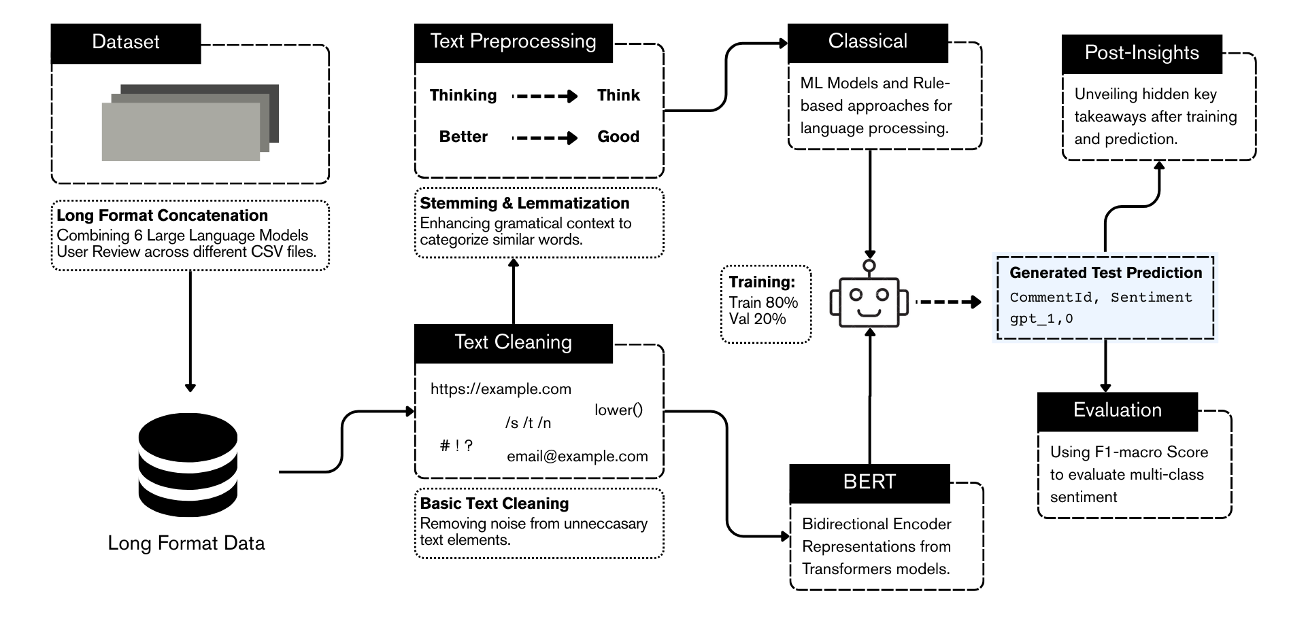
Figure 3.1. Experiment flow diagram
As shown in Fig. 3.1, the steps conducted in this analysis include dataset cleaning, training the Classical and BERT model followed by doing a model performance comparison, and evaluation. The dataset used in this study comes from the Data Analysis Competition 2025 by Sepuluh Nopember Institute of Technology [12].
The dataset consists of user review collections $X∈ℝ^{P×n}$ representing sentiment-labelled comments from major Large Language Model platforms, where dimension $P$ denotes the total number of platforms observed, with $n$ number of user reviews for each platform. The reviews are sourced from Claude, DeepSeek, Gemini, GPT, Grok, and Perplexity, distributed across platform-specific CSV files.
The total number of user reviews in the dataset is 176,856 reviews across all platforms, divided into training and test data. The training data consists of 130,885 reviews used to train the model, whereas the test data consists of 45,971 reviews used to evaluate the model. Each review entry contains structured attributes including textual comment, timestamp, application version, and sentiment label.
Sentiment annotations are categorized into three classes: negative (0), neutral/mixed (1), and positive (2). The dataset exhibits pronounced class imbalance characteristics typical of user-generated content, where positive sentiments significantly outnumber negative and neutral categories across all platforms.
The initial step involves long-format concatenation of user reviews from the six LLM platforms' CSV files. This combines disparate datasets into unified train.csv and test.csv files, preserving metadata like timestamps and app versions, to create a cohesive long-format dataset suitable for downstream processing.

Basic text cleaning is applied to remove noise from unnecessary elements in the reviews. This includes stripping URLs (e.g., https://example.com), special characters (e.g., /s, /t, /n, #, !, ?), emails (e.g., email@example.com), and converting text to lowercase, ensuring cleaner input for subsequent steps.
For the classical models, additional preprocessing is applied following cleaning, including stemming and lemmatization to enhance grammatical context and categorize similar words. This reduces morphological variations (e.g., "thinking" to "think," "better" to "good") while preserving meaning, improving the quality of features for classical model input.
Initial language processing employs classical machine learning models and rule-based methods as baselines for sentiment classification. These use techniques like bag-of-words or TF-IDF vectorization combined with classifiers such as logistic regression or GBDT, applied to the preprocessed text to establish comparative performance metrics.
The dataset is split into 80% training and 20% validation sets. Both classical models (post-preprocessing) and the BERT model (post-cleaning only) are trained or fine-tuned on the training data for multi-class sentiment classification. BERT leverages its bidirectional transformer architecture to capture contextual nuances in reviews, while classical models rely on traditional feature extraction. Hyperparameters are optimized during validation to minimize overfitting.
Using the trained classical and BERT models, predictions are generated on the unseen test data. Outputs include CommentId and predicted sentiment labels (0, 1, or 2), formatted as required.
Model performance is assessed using the F1-macro score, which computes the unweighted average of per-class F1 scores. This metric evaluates multi-class sentiment classification fairly, accounting for class imbalance by treating negative, neutral, and positive classes equally.

CHAPTER IV: Analysis of Results

Sentiment Classification Modeling
Before diving deep into modeling, Exploratory Data Analysis (EDA) serves as the critical initial step in the sentiment classification modeling process, aimed at understanding the dataset's characteristics to inform subsequent modeling decisions. EDA reveals significant class imbalance, with positive sentiments dominating at 82.3% (107,774 reviews), negative sentiments at 13.4% (17,522 reviews), and neutral/mixed sentiments underrepresented as a minority class at 4.3% (5,589 reviews), as illustrated in Fig. 4.1.
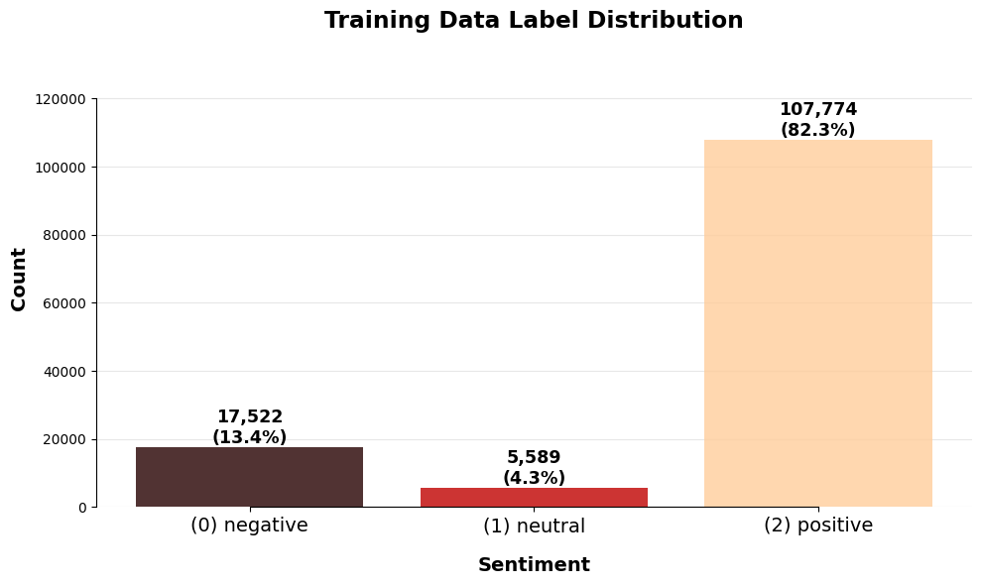
Figure 4.1. Training data sentiment distribution
Additionally, EDA identifies poor labeling practices, notably the ambiguous labeling of short positive terms like "good," "nice," "best," and "good 👍" as neutral (1) rather than positive (2), as shown in Fig. 4.2, introducing noise and potential misclassification risks.
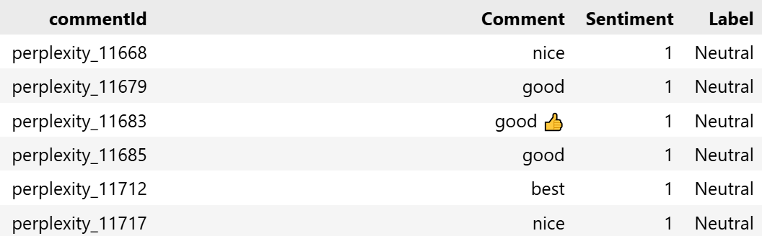
Figure 4.2. Poor labeling examples
These insights directly shape the modeling strategy, highlighting the need for techniques to address class imbalance and mitigate the impact of ambiguous labels. For instance, recognizing that neutral/mixed is a minority class suggests that assigning higher weights to this class during training will help the model prioritize learning its patterns, improving overall performance.
To prepare the raw review data for modeling, a comprehensive preprocessing pipeline is applied to standardize the text and reduce noise. All text is converted to lowercase to ensure uniformity, eliminating case-related discrepancies. Special elements such as URLs, email addresses, and user mentions are replaced with placeholders (e.g., "[url]", "[email]"), and hashtags are stripped of their prefixes to focus on their content. Non-alphanumeric characters, except for basic punctuation (., !, ?, -), are removed, and multiple spaces are normalized to a single space. Empty or invalid reviews are filtered out to maintain data quality.

Given the EDA finding that neutral/mixed sentiments are a minority class, the modeling strategy employs class weighting to address this imbalance, prioritizing the minority class to enhance model performance. Higher weights are assigned to the neutral/mixed class (1) compared to the dominant positive class (2), ensuring that misclassifications of neutral/mixed sentiments incur a greater penalty during training. This approach, integrated into the loss function, avoids the data loss associated with undersampling, preserving the full dataset of 130,885 training reviews for better generalization across the six LLM platforms. By emphasizing the minority class, the model learns to better distinguish neutral/mixed sentiments, counteracting the bias toward positive labels and addressing the ambiguity in labels for terms like "good."
For the BERT model, the pipeline relies on the transformer's tokenizer to handle morphological variations, simplifying the preprocessing workflow while maintaining effectiveness. However, for classical models used as baselines, additional stemming and lemmatization are applied to reduce words to their base forms (e.g., "thinking" to "think," "better" to "good"), further enhancing feature quality.
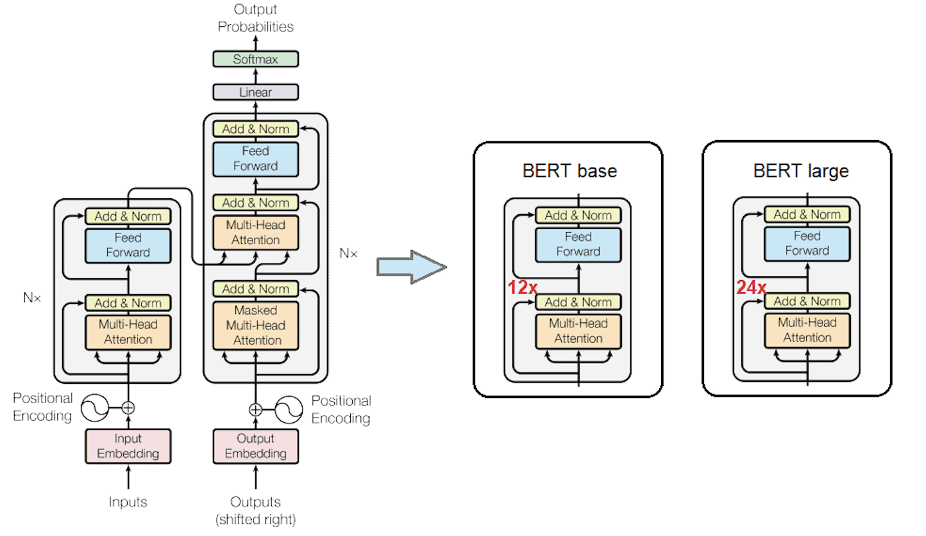
Figure 4.3. BERT based model architecture
The preprocessed text is tokenized to convert it into numerical inputs suitable for a transformer-based model. This process involves breaking text into tokens, truncating sequences to a maximum length of 320 tokens to accommodate lengthy reviews, and generating attention masks to handle variable-length inputs. Tokenization is performed efficiently in batches, with padding applied dynamically during prediction to optimize memory usage. This step ensures that the text is formatted appropriately for the transformer model, enabling effective feature extraction and capturing contextual nuances in user reviews.
The modeling approach leverages a multilingual transformer model (xlm-roberta-base) tailored for diverse LLM user reviews, extracting contextual embeddings that capture nuanced semantic relationships. These embeddings are aggregated using a Generalized Mean (GeM) pooling mechanism, which computes a learnable powered average of token embeddings, weighted by attention masks. This pooling method balances max and mean pooling, providing a robust representation of the text. A dropout layer with a 0.1 probability is applied to prevent overfitting, followed by a linear classifier that maps the pooled embeddings to the three sentiment classes.
Classical machine learning models, such as logistic regression or TF-IDF features, were employed as baselines to establish comparative performance, but the transformer architecture was selected for its superior handling of complex textual patterns in informal reviews.
The transformer model is fine-tuned over five epochs with a learning rate of 2e-5, a batch size of 20, and 1000 warmup steps, using the AdamW optimizer with a weight decay of 0.01 for regularization. The class weights, emphasizing the minority neutral/mixed class, are incorporated into the loss function to address the imbalance identified in EDA.
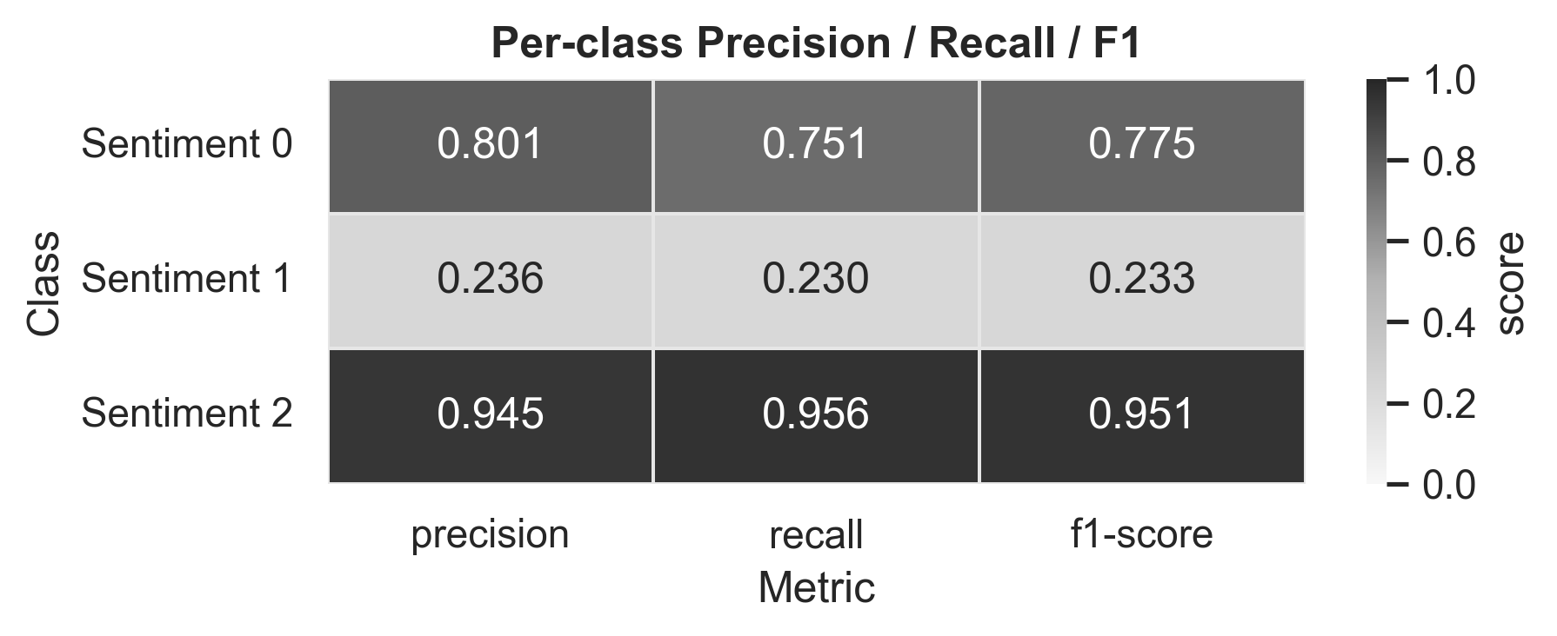
Figure 4.4. Classification report from embedding method using XLM-RoBERTa
Performance is evaluated using accuracy, macro F1-score, and weighted F1-score, with the macro F1-score as the primary metric to ensure balanced performance across classes, particularly for the underrepresented neutral/mixed label. On the validation set (20% split, approximately 25,653 samples), the model achieved an accuracy of 0.8973, a macro F1-score of 0.6530, and a weighted F1-score of 0.8961, as detailed in the classification report. Precision for negative (0) was 0.8011 with recall 0.7511, for neutral/mixed (1) precision 0.2360 with recall 0.2300 (highlighting challenges with the minority class), and for positive (2) precision 0.9452 with recall 0.9562. This fine-tuning process adapts the model to not hardly overkill into certain characteristics, that might trap it into the ambiguous poor labeling issue.
For the test dataset (45,971 reviews), the same preprocessing and tokenization steps are applied to ensure consistency. Predictions are generated in batches using the fine-tuned model, producing sentiment labels that account for the weighted emphasis on the neutral/mixed class.

Section 2: Insights from User Reviews
To derive deeper insights from user feedback, the analysis focuses on negative reviews to uncover common complaints and examines how sentiment evolves across app versions. Negative reviews, labeled as 0, are extracted from the concatenated training dataset for each of the six LLM platforms (Claude, DeepSeek, Gemini, GPT, Grok, and Perplexity). This subset comprises approximately 17,522 reviews, representing 13.4% of the total training data. These reviews are preprocessed similarly to the sentiment classification pipeline, including text cleaning to remove noise such as URLs, emails, and special characters, followed by tokenization and stop-word removal to prepare for topic modeling.
Topic modeling is applied using a combination of TF-IDF (Term Frequency-Inverse Document Frequency) for keyword extraction and Latent Dirichlet Allocation (LDA) to identify latent themes within the negative reviews. TF-IDF highlights high-frequency terms unique to complaints, while LDA groups them into coherent topics (set to 3 based on coherence score optimization).

Table 4.1. Top Topics from Topic Modelling
Topic | Top Words
#1 | good, use, don, worst, useless
#2 | app, time, server, busy, gemini
#3 | bad, ai, google, like, working

The unexpected prominence of "good" as a top word across topics (e.g., Topic #1: good, use, don, worst, useless) suggests potential mislabeling from the earlier poor labeling analysis, where positive sentiment may have been incorrectly tagged as negative. This anomaly likely skews the topics, masking true complaints. Other notable terms like "worst" and "useless" indicate genuine dissatisfaction, though their impact is diluted by the labeling issue.
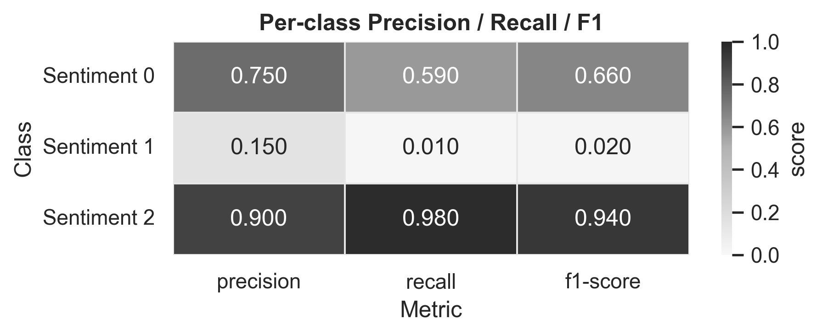
Figure 4.5. Classification report from rule-based method using TF-IDF

Fig. 4.5. presents the classification report for the rule-based method using TF-IDF, detailing per-class metrics: for negative sentiment (0), precision 0.750, recall 0.590, F1 0.660; for neutral/mixed (1), precision 0.150, recall 0.010, F1 0.020 (highlighting severe challenges with the minority class); and for positive (2), precision 0.900, recall 0.980, F1 0.940. This yields a lower overall performance (e.g., macro F1 ≈0.540) compared to the BERT-based model (macro F1 0.653), as BERT's contextual embeddings capture semantic nuances, word relationships, and context better than TF-IDF's simplistic term frequency approach, improving handling of imbalances and subtle sentiments.
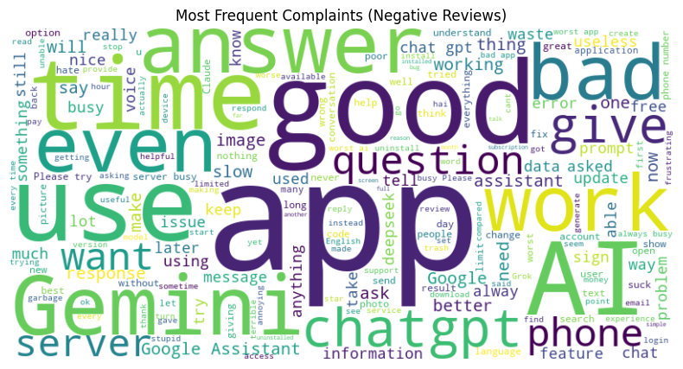
Figure 4.3. Negative review wordcloud
The most frequent complaints are visualized in a wordcloud (Figure 4.3), where larger words reflect higher occurrence. Despite the labeling confusion with "good," prominent terms reveal user frustrations with unresponsive servers, inaccurate answers, and app reliability. Common pain points include slow response times ("time," "slow," "busy"), poor AI performance ("bad," "wrong," "useless"), and feature integration issues ("image," "voice," "google assistant"). The presence of "good" in the wordcloud further supports the hypothesis of poor labeling, potentially inflating positive connotations within negative reviews, though platform-agnostic complaints remain evident, with Gemini and GPT showing heightened frustration.
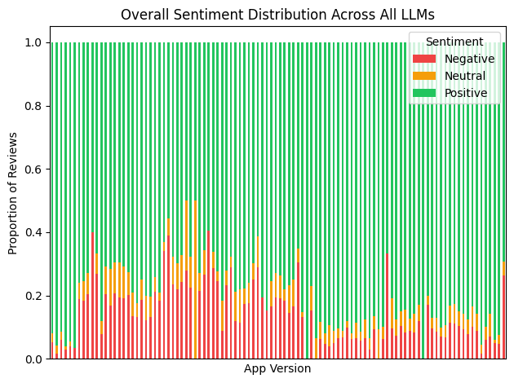
Figure 4.4. Overall sentiment distribution by App Version across all LLMs

Version-based sentiment analysis is conducted by grouping all reviews (positive, neutral/mixed, and negative) by the "AppVersion" attribute, which is available in the metadata for most entries. For each version, the proportion of each sentiment class is calculated as the count of reviews in that class divided by the total reviews for the version. The overall sentiment distribution across all LLMs, as depicted in the Fig 4.4, shows a clear pattern: earlier app versions (e.g., below 1.0) exhibit higher proportions of negative and neutral sentiments, with spikes in negativity around versions 1.2 to 1.5, potentially corresponding to major updates or bug introductions. As versions progress (e.g., beyond 2.0), positive sentiments dominate, indicating improvements over time.

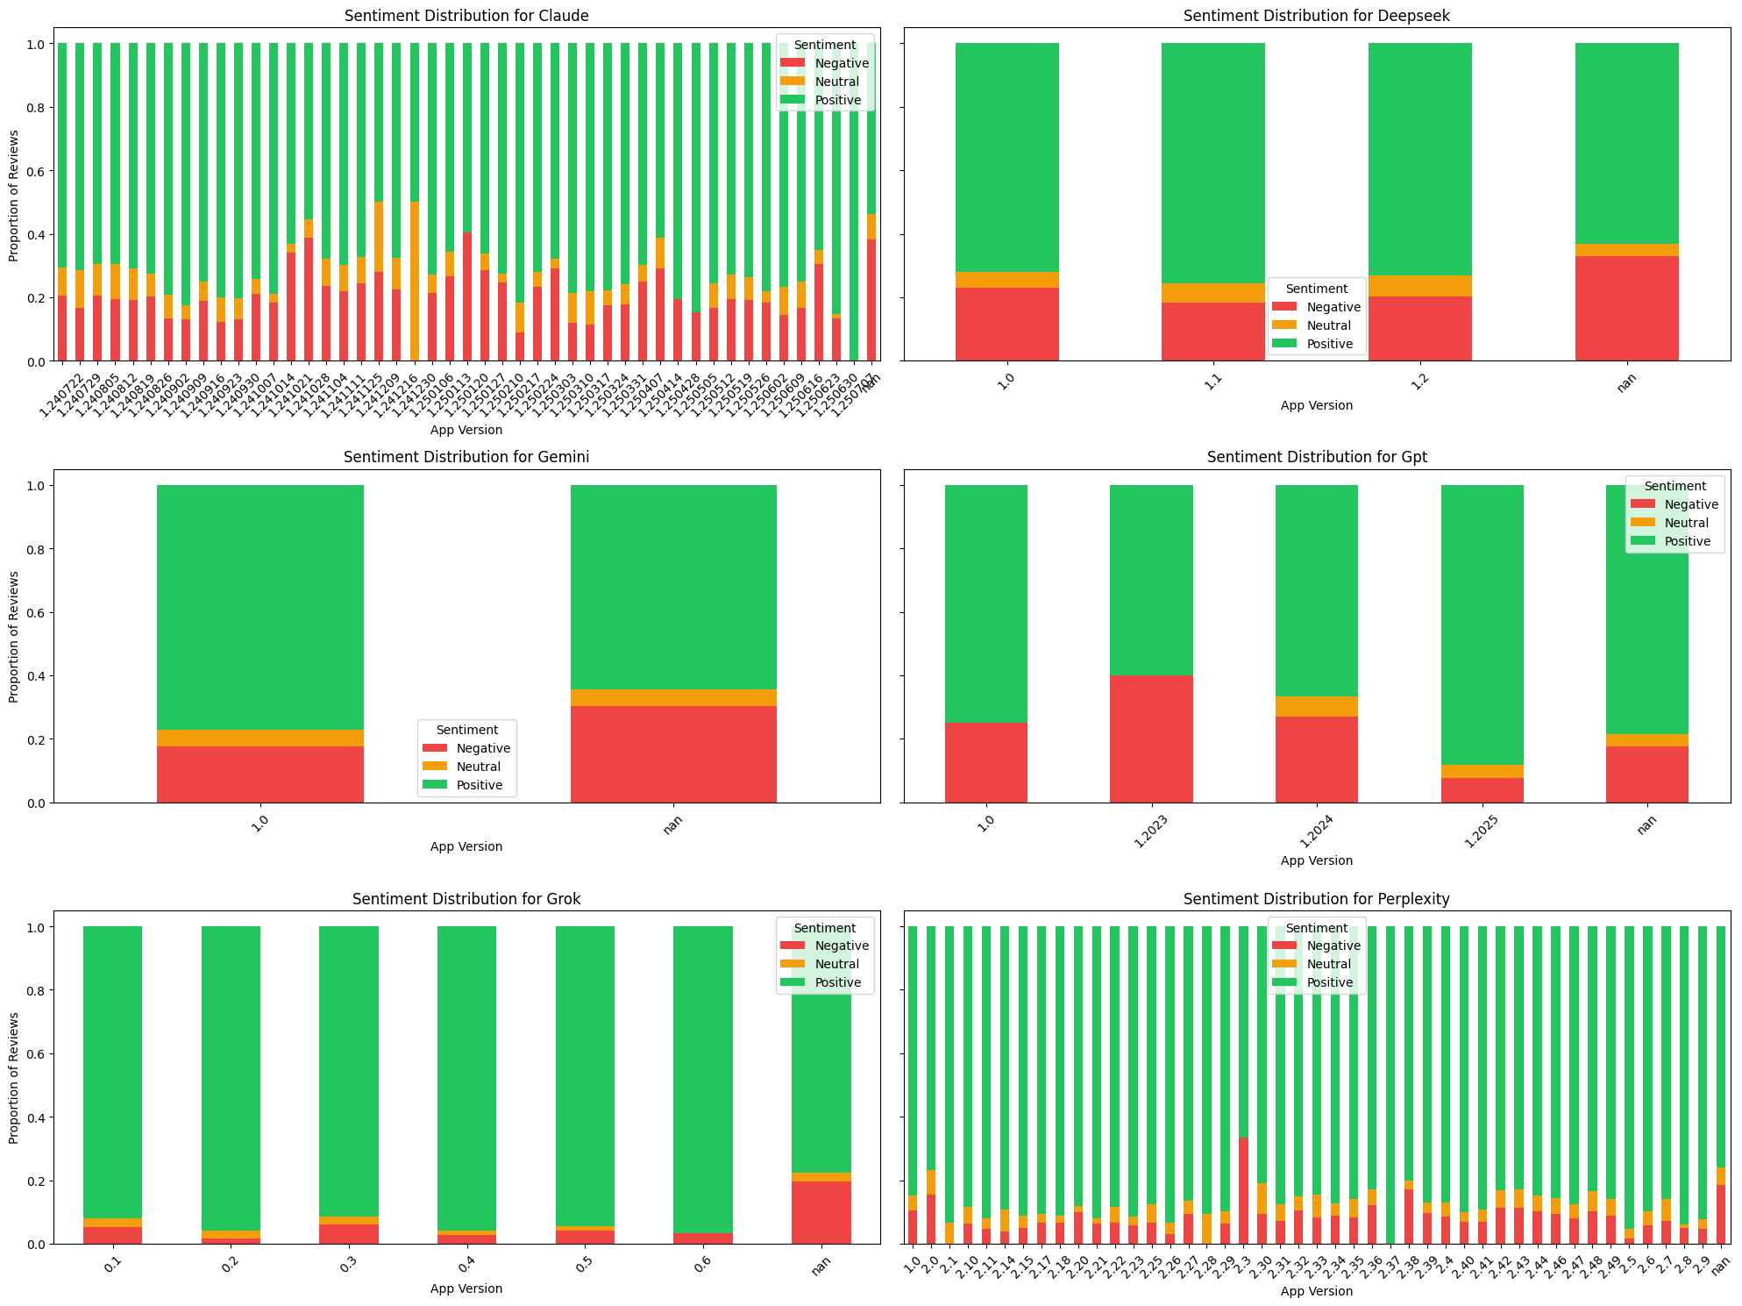
Figure 4.5. Each LLM’s sentiment distribution by App Version
Platform-specific visualizations further elucidate these trends, as shown in the subplots for each LLM. For Claude, with numerous versions from 1.4.2279 to 1.2500.20, negative proportions are high in early releases (e.g., over 40% in 1.4.x) but decrease steadily, suggesting iterative fixes. DeepSeek, with limited versions (1.0 to 1.2), shows balanced but volatile sentiments, with a notable neutral spike in 1.1. Gemini's chart reveals persistent negative layers in versions like 1.0 and nan, possibly tied to integration bugs with Google services. GPT displays improving trends from 1.0 to 1.2025, with negativity dropping below 10% in later versions. Grok, covering 0.1 to 0.6, maintains mostly positive stacks with minimal
negativity, reflecting a stable user experience. Perplexity, with the most granular versions (1.0 to 2.6), mirrors the overall pattern, with early versions (1.0-1.5) dominated by red and orange, transitioning to green in 2.x, indicating successful updates.
Comparative insights across platforms reveal shared patterns, such as elevated negativity in initial releases, often linked to common complaints like server busyness or AI inaccuracies from the topic modeling. Persistent issues, like "subscription" and "pay" mentions in negative reviews, appear in Grok and Claude, pointing to monetization frustrations. Shifts over time include a reduction in "bug" and "crash" terms in later versions for Perplexity and Claude, suggesting bug fixes in updates.
CHAPTER V: Conclusion and Recommendation
The analysis of user reviews across six LLM platforms (Claude, DeepSeek, Gemini, GPT, Grok, and Perplexity) underscores the rapid growth in AI adoption, with 78% of businesses integrating AI into at least one task and 71% adopting generative AI by 2024, alongside nearly two billion global AI tool users projected by 2025.
Exploratory Data Analysis (EDA) revealed critical dataset characteristics, including a pronounced class imbalance where positive sentiments dominated at 82.3% (107,774 reviews), negative sentiments accounted for 13.4% (17,522 reviews), and neutral/mixed sentiments were underrepresented at 4.3% (5,589 reviews). This imbalance posed challenges for model training, potentially biasing predictions toward the majority positive class. Additionally, EDA identified poor labeling practices, such as ambiguous classifications of short positive terms like "good," "nice," and "best," and as neutral rather than positive, introducing noise that could lead to misclassifications and skew subsequent analyses, such as topic modeling where "good" anomalously appeared as a top word in negative reviews.
To address these issues, a comprehensive preprocessing pipeline was implemented, involving text cleaning to remove noise like URLs, emails, special characters, and converting text to lowercase for uniformity. For classical models, further steps included stemming and lemmatization to reduce morphological variations (e.g., "thinking" to "think," "better" to "good"), enhancing feature quality. The modeling strategy incorporated class weighting to prioritize the minority neutral/mixed class, integrating it into the loss function to mitigate imbalance without data loss, while leveraging the transformer's tokenizer for BERT-based approaches to handle contextual nuances efficiently.
Sentiment analysis using transformer-based models, particularly XLM-RoBERTa, achieved a macro F1-score of 0.653 on the validation set, outperforming TF-IDF-based methods (macro F1 ≈0.540) due to superior semantic capture of word relationships and context, which better managed imbalances and subtle sentiments. Topic modeling of negative reviews uncovered recurring complaints about server issues, AI accuracy, and app reliability, though diluted by labeling anomalies. Version-based analysis demonstrated improving user sentiment in later app releases (e.g., beyond 2.0), with reduced negativity linked to iterative fixes across platforms.
Recommendations include refining dataset labeling processes to eliminate ambiguities, such as re-evaluating short positive phrases for accurate classification, and enhancing preprocessing pipelines with advanced techniques like handling sarcasm or emojis for noisier reviews. Developers should prioritize addressing user complaints, such as server performance and monetization frustrations (e.g., "subscription" issues in Grok and Claude), through targeted updates. Future research could explore multilingual sentiment nuances, incorporate real-time review monitoring, and test hybrid models combining transformers with classical methods for even greater robustness in handling imbalanced, noisy datasets.

REFERENCES
[1] | S. Carolan, A. Wu, C. C. Gong, and S. Korus, 2025: The State of Consumer AI, San Francisco, CA, USA: Menlo Ventures, Jun. 2025. [Online]. Available: https://menlovc.com/perspective/2025-the-state-of-consumer-ai/
[2] | McKinsey & Company, The state of AI: How organizations are rewiring to capture value, New York, NY, USA: McKinsey Global Survey on AI, 2025. [Online]. Available: https://mckinsey.com/capabilities/quantumblack/our-insights/the-state-of-ai
[3] | Stanford Institute for Human-Centered Artificial Intelligence (HAI), AI Index 2025 Report, Stanford, CA, USA: Stanford University, 2025. [Online]. Available: https://hai.stanford.edu/ai-index/2025-ai-index-report
[4] | S. De Kok et al., Review-level aspect-based sentiment analysis using an ontology, in Proc. 33rd Annu. ACM Symp. Appl. Comput., Pau, France: ACM, 2018, pp. 315-322. doi: 10.1145/3167132.3167163
[5] | T. Sultan, N. Jahan, R. Basak, M. S. A. Jony, and R. H. Nabil, Machine learning in cyberbullying detection from social-media image or screenshot with optical character recognition, Int. J. Intell. Syst. Appl., 15:1–13, 2023.
[6] | S. Dey, S. Wasif, D. S. Tonmoy, S. Sultana, J. Sarkar, and M. Dey, A comparative study of support vector machine and naive bayes classifier for sentiment analysis on amazon product reviews, in Proc. Int. Conf. Contemp. Comput. Appl. (IC3A), Lucknow, India: IEEE, 2020, pp. 217-220. doi: 10.1109/IC3A48958.2020.233300
[7] | Devlin, M.-W. Chang, K. Lee, and K. Toutanova, BERT: Pre-training of Deep Bidirectional Transformers for Language Understanding, arXiv preprint arXiv:1810.04805, 2018. [Online]. Available: https://arxiv.org/abs/1810.04805
[8] | M. I. Ragab, E. H. Mohamed, and W. Medhat, Multilingual Propaganda Detection: Exploring Transformer-Based Models mBERT, XLM-RoBERTa, and mT5, in Proc. 1st Int. Workshop Nakba Narratives as Language Resources, 2025, pp. 75–82. [Online]. Available: https://aclanthology.org/2025.nakbanlp-1.9.pdf
[9] | N. Jahan, J. Ahamed, and D. Nandi, Enhancing E-commerce Sentiment Analysis with Advanced BERT Techniques, Int. J. Inf. Eng. Electron. Bus., vol. 17, no. 3, pp. 49-61, 2025. [Online]. Available: https://www.mecs-press.org/ijieeb/ijieeb-v17-n3/IJIEEB-V17-N3-4.pdf
[10] | M. S. W. Dewi, S. Nabila, and S. G. Hilaly, Analisis Kepuasan Pengguna terhadap Kualitas Layanan Portal Layanan Mahasiswa (POLAM) Menggunakan Metode Servqual, J. Teknologi dan Sist. Inf., vol. 4, no. 2, pp. 198-207, 2023. [Online]. Available: https://jutif.if.unsoed.ac.id/index.php/jurnal/article/view/4010
[11] | C. A. Putri et al., Sentiment Analysis of KAI Access App Customer Reviews to Improve Customer Service Using Natural Language Processing, ResearchGate, 2024. [Online]. Available: https://www.researchgate.net/publication/394720671_Sentiment_Analysis_of_KAI_Access_App_Customer_Reviews_to_Improve_Customer_Service_Using_Natural_Language_Processing
[12] | Sepuluh Nopember Institute of Technology, Data Analysis Competition 2025 Dataset, Kaggle, 2025. [Online]. Available: https://www.kaggle.com/competitions/data-analysis-competition-2025/data

